**INTRODUCTION:**

**India has a rich history of Agricultural dating back thousands of years. Agricultural is a crucial part of the country's economy and culture . India's diverse climate and geography allow for the cultivation of a wide variety of crops. Major crops include;**

**Rice**

**Wheat**

**Maize**

**Sugarcane**

**Cotton**

**Pulses**

**Agricultural is primarily rain-fed, but irrigation plays a signification role, particularly in areas with unreliable rainful.Its gross irrigated crop area of 82.6 million hectares is the largest in the world.**

**Problem Definition & Design Thinking**

Empathy Map:

**An empathy map is a visual tool used to understand and empathize with a particuler user or customer segment. The map typically consists of four key quadrants: "Says", "Thinks", "Does", and "Feels", user's experience and perspective.**

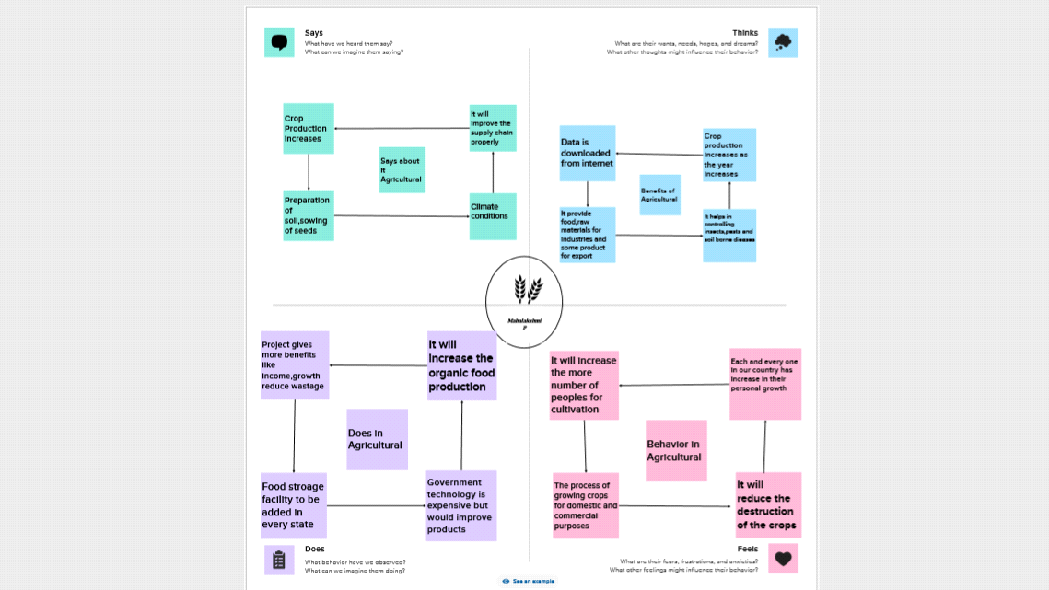

**Ideation & Brainstroming Map**

**A barinstorm map into is a visual representation of ideas and concepts , typically used to generate, organize,and explore thoughts.Plan projects,and make complex information more manageable.**

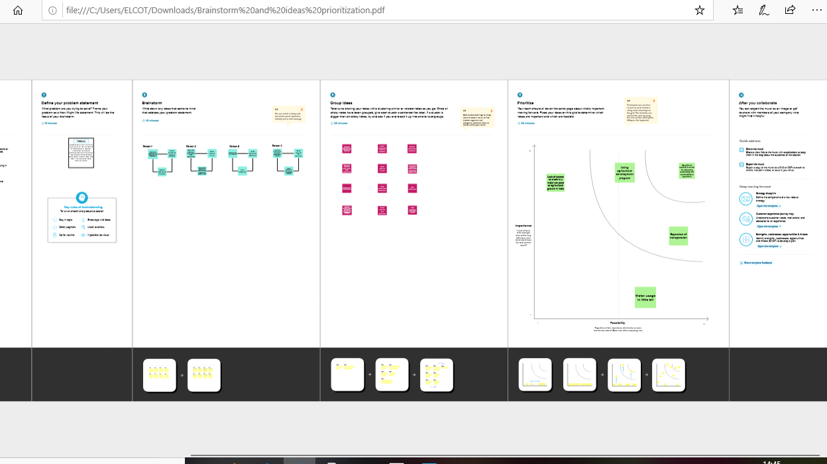

**RESULT**

**Dashboard: 1**

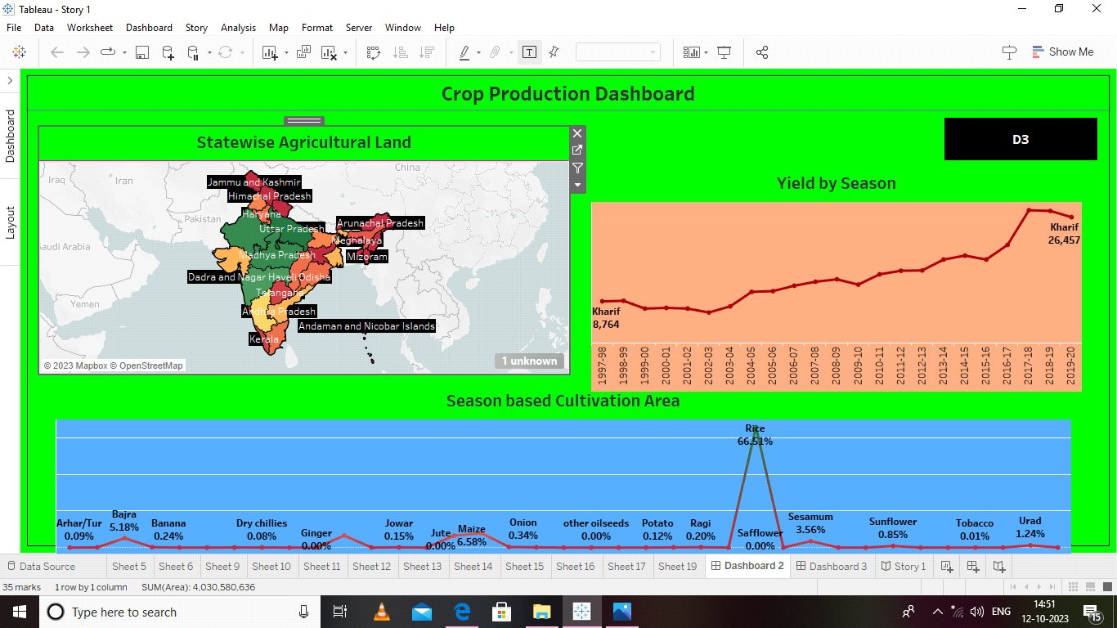

**Dashboard: 2**

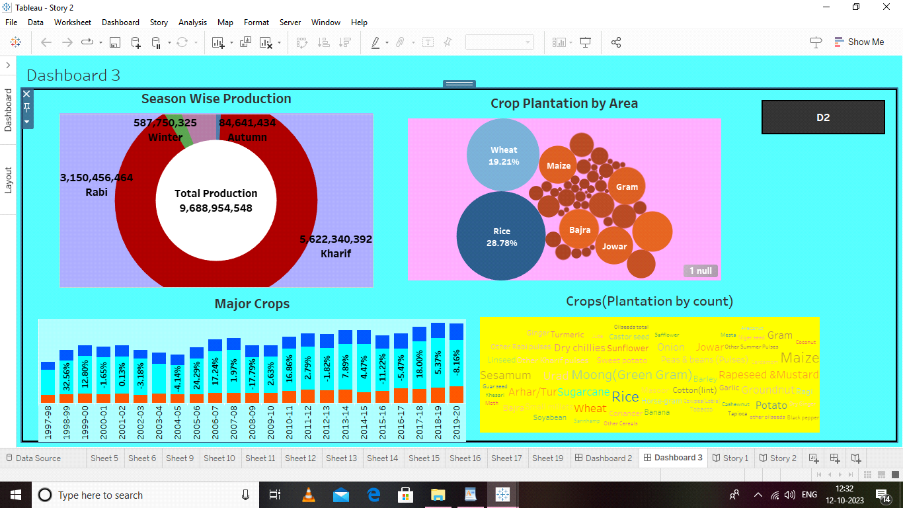

**Story: 1**

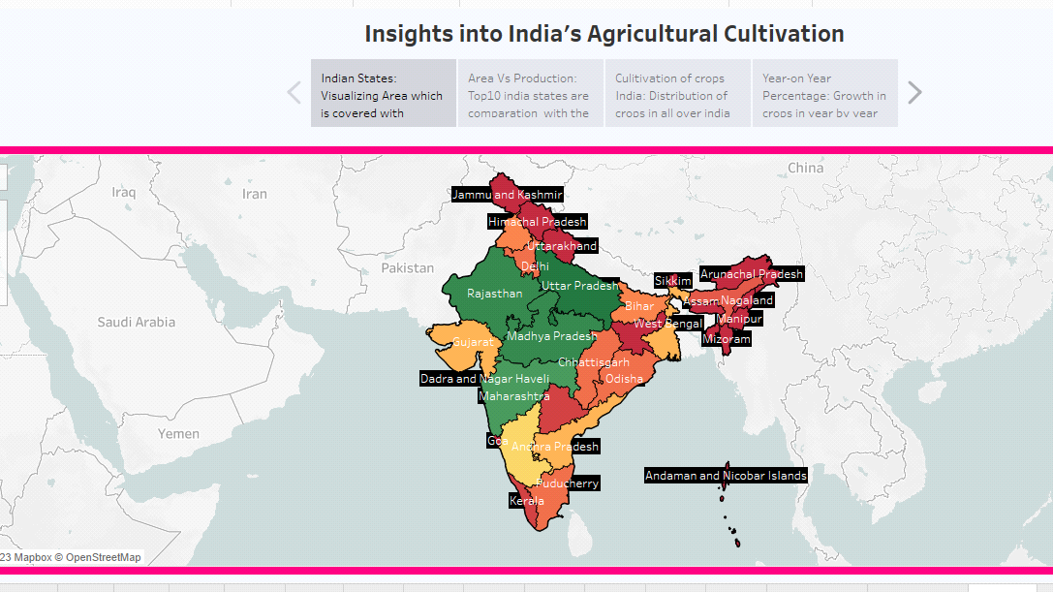

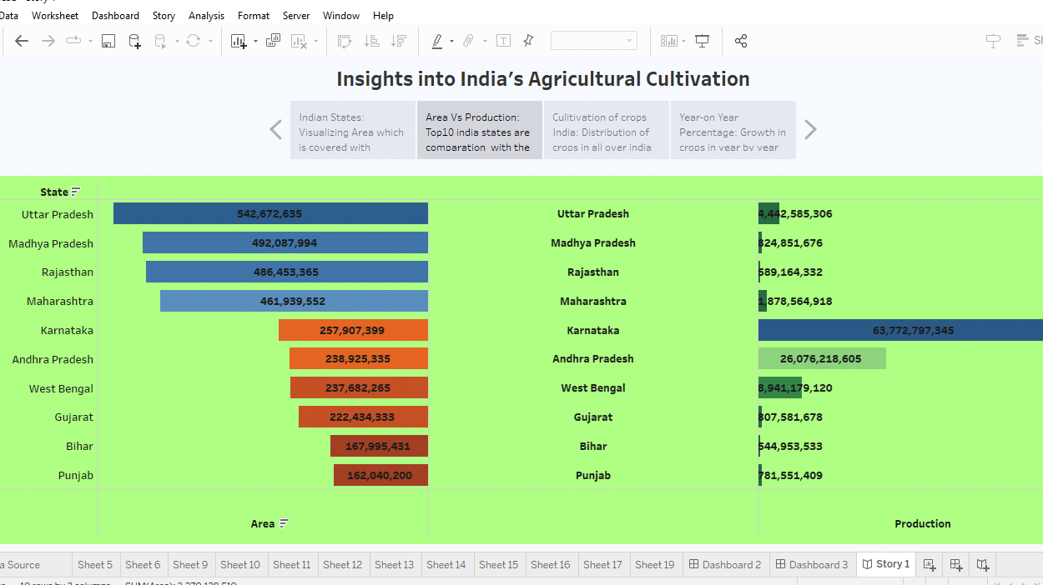

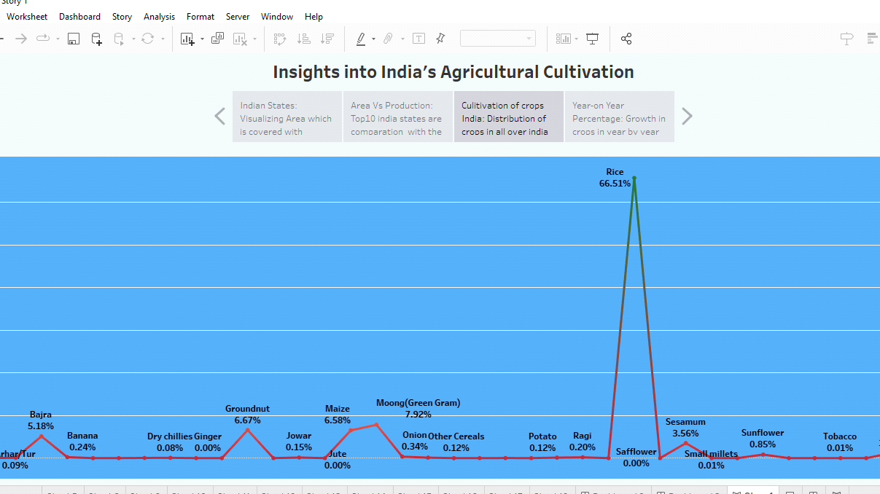

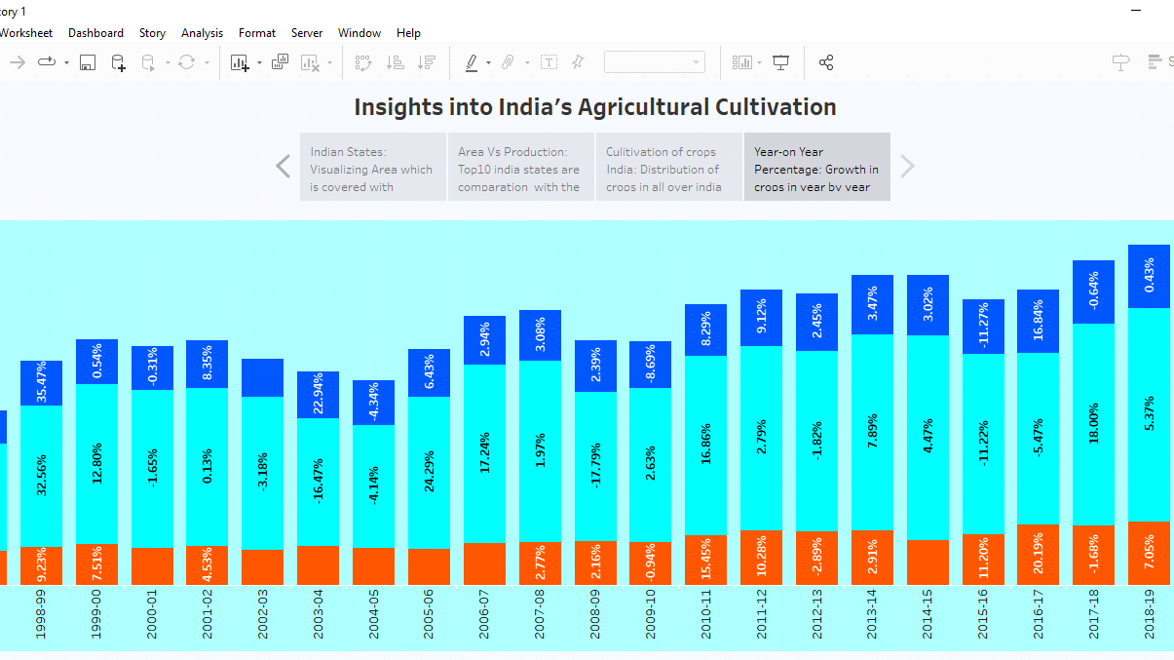

**Story: 2**

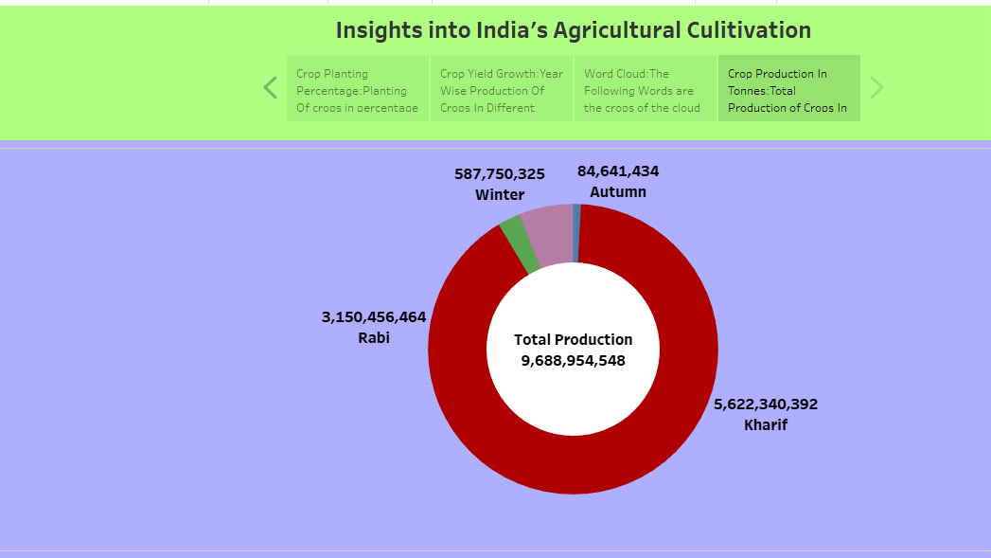

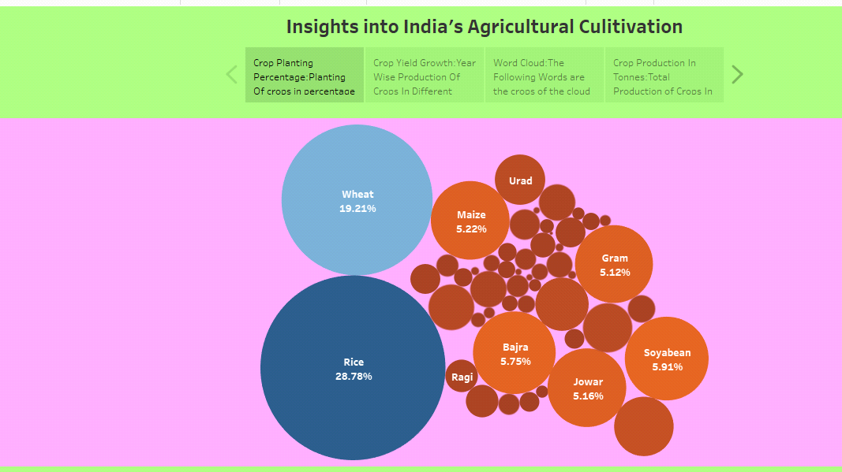

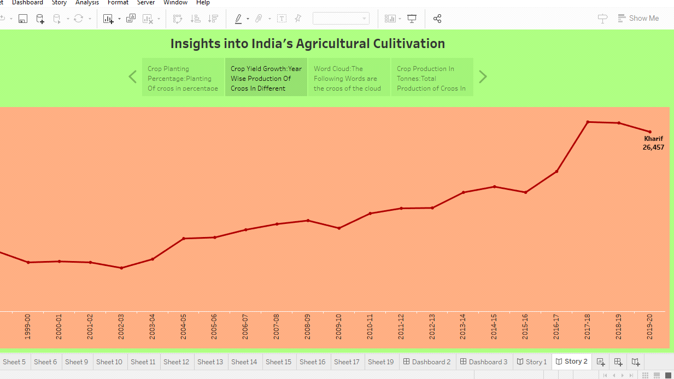

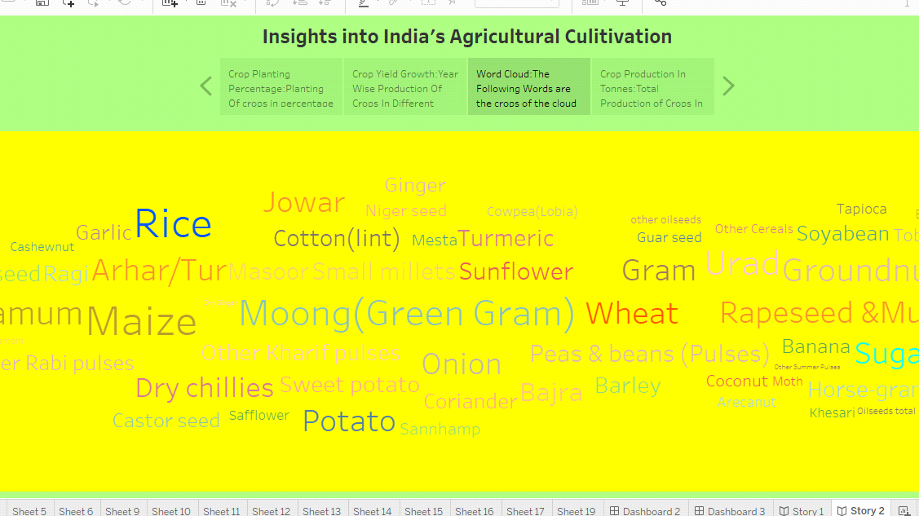

**ADVANTAGES & DISADVANTAGES**

**Advantages:**

* + 1. **Diverse Agroclimatic Zones: India's geographical diversity allows for the cultivation of a wide range of crops.**
    2. **There is over all increases in yield of crops mainly due to maintaning physical, chemical properties of soil.**
    3. **It helps in controlling insects, pests, and soil borne diseases.**
    4. **Prevent or limit periods of peak ewquirements of irrigation water.**

**Disadvantages:**

* + - **Erosion of soil by heavy rain, floods, insufficient, vegetation cover etc., reduces form productivity.**
    - **Limited knowlege and insufficient infrastructure.**
    - **There is no insurance against crop failure.**
    - **Agriculture contributes to greenhouse gas emissions,and changing climate patterns can lead to unpredictable growing conditions and crop failures.**

**APPLICATIONS**

* **Food security:**
  + - **The primary application of crop production is to ensure food security of india's vast population.crops like rice, wheat, and pulses are grown to meet the dietary needs of millions.**
* **Raw materials and industry:**
  + - **Crops like sugarcane and oil seeds serve as raw materials foe various industries. Sugarcane is used in sugar and ethanol preduction, while oilseeds yield edible oils.**
* **Research and development:**
  + - **Crop production is integral to agricultural research and development, with scientists working to improve crop varieties and farming techniques.**

**CONCLUSION**

**In conclusion, agriculture and crop production are fundamental to india's economy culture and livelihoods. Crop production in india extends beyond basic sustenance contributing to the nations rich tapestry of culture traditions and ecnomic growth, It remains a vital component of india's indensity and its pursuit of susrainable and inclusive development.**

**Future Scope**

* **Precision Agricultural: Increasing adoption of technology such as drones sensors, and data analytics, will enable farmers to optimize crop management, reduce resourse use, improve yields.**
* **Vertical Forming: Controlled environment agriculture, including vertical farming, will enable year-round crop production in urbun areas, conserving land and resources.**
* **Consumer Trends: Shifting consumer preferences for healthy, locally sourced,and subtainably grown crops will influence production methods and crop selection.**